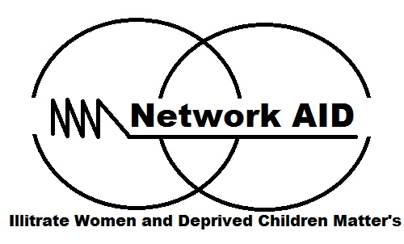
Network AID Application Form

BASIC INSTRUCTIONS
- All information collected on this application form is held in the strictest confidence.
- Please read the job description for the above position carefully before completing this application form.
- Short-listing will be carried out solely on the basis of information provided on this application form. CVs will not be considered.
- At the email subject line insert your name_country_post applying for.
- Please complete and return/email this application form to jobs@networkaid.org copy nnetaid@gmail.com
BASIC APPLICATION FORM
Brief Organisational Background
- Seeks to promote and protect the welfare and well being of illiterate women/girls, young people, persons with disability and deprive children.
- Legally registered.
- Operate in seven countries at the moment.
- Programmatic Focus: - Livelihood & Education; Health & Safety; Governance & Participation.
- Have equal employment opportunity irrespective of creed, race, religion etc
- For more information www.networkaid.org.

Eligibility Criteria for Applicant
- Applicant must have an experience or knowledge in the field you are applying for; any additional skills is an added advantage.
- Terms of Reference/Agreement signed between the volunteer and Network AID.
- International applicant MUST secure medical insurance before traveling

AREA APPLYING FOR

Please specify the position applying for:-

- ..................................................................................................................

1. PERSONAL DETAILS
Family Name
First Name
Nationality
Country of Residence
Contact Address
Mobile Number
Home Number
Website and Email Address
Skype ID
Twitter ID
Facebook ID
LinkedIn ID
Instagram ID
What motivated you to Apply (100 words)
State your ability to deliver on the role and expectation from the organisation (200 words)
Have you worked in a similar position before?
If yes, please provide details (150 words)

2. EDUCATIONAL DETAILS
College/University Attended | Main Subject Studied | Level Attained | Dates (From-To)

3. FURTHER RELEVENT TRAINING / COURSES (undertaken in last 5 years)
Institutions/Organisation | Training/Courses | Certificate Attained | Dates (From–To)

4. LANGUAGE SKILLS – (1=Fluent; 2=Fair; and 3=Poor)
ENGLISH | Spoken
ENGLISH | Written
OTHER (please specify) | Spoken
OTHER (please specify) | Written
OTHER (please specify) | Spoken
OTHER (please specify) | Written
OTHER (please specify) | Spoken
OTHER (please specify) | Written

5. ADDITIONAL SKILLS
Do you drive or ride and hold licence (motorbike or car etc)? if yes which category
Computer skills/software systems: please indicate

6. LAST VOLUNTEERING AND ORGANISATION IF ANY
Organisation/Institution
Position Held
Summary of Role & Key Achievements at least five
Date (from – to)
Reason for leaving

7. Work EXPERIENCE WITHIN THE LAST 3 YEARS IF ANY
Organisation & Country | Position Held | Summary of Role & 3 Key Achievements | Dates (from–to)

8. DECLARATION
I.............................(APPLICANT NAME) ......................................confirm that the information provided in this application is, to the best of my knowledge, true and complete. I understand and agreed that any false statement may lead to disqualification.

Signed Applicant

…………………………………………….

Date…………………..................................

EQUAL OPPORTUNITIES & RECRUITMENT EVALUATION

As with all appointments across Network AID, this recruitment process will adhere to the organisation’s policies with equal opportunities. The summary of which sets out that:
Network AID seeks to recruit and develop volunteers from all sectors of the community and will ensure that no applicant or incumbent receives less favourable treatment on the grounds of gender, sexual preference, marital status, social status, caste, race, ethnic origin, religious belief, age, HIV status, disability, or any other factor that cannot be shown to be relevant to performance.
Due to our basic fundamental principles and beliefs, Network AID is particularly committed to monitoring the representation and diversity of our staff, volunteers or interns in relation to youth, disability, gender, nationality and area of operation.
The information requested below is requested to assist the organisation in monitoring its equal opportunity policy and evaluating responses to our internal and external advertising. While the information you give below will be used for statistical analysis by the organisation, no names will be associated with those statistics, nor will it influence this application process.

Position Applied for:
How did you hear about this call?
Have you previously applied for any area with Network AID? (if yes, please outline):
How do identify you identify yourself gender?
What is your country of origin?
What is your country of residence?
What is your date of birth?
How do you hear of this advert?

